ELEMENTARY 1

UNIT 1

1: Family Members: watch the following video

<https://www.youtube.com/watch?v=d_WQEw13TCo>

[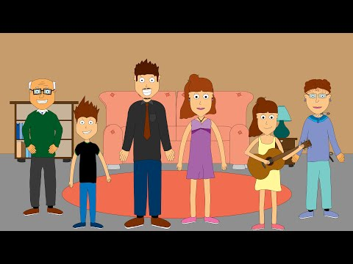](https://www.youtube.com/watch?v=d_WQEw13TCo)

Quiz: <https://wordwall.net/es/resource/17796061/family-members1>

Complete this quiz and include a screenshot of your results:

(Paste the screenshot here)

2: Describing People: Watch the following video

<https://www.youtube.com/watch?v=V6x4hUIO1Os>

Matching Activity:

<https://wordwall.net/resource/11556046/esol/describing-people>:

Complete this quiz and include a screenshot of your results:

(Paste the screenshot here)

[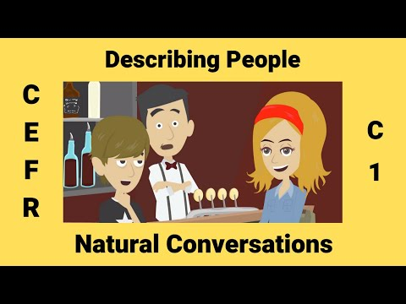](https://www.youtube.com/watch?v=V6x4hUIO1Os)

**Reading activity:**

Hi! My name is Sam. I am 7 years old. I want to tell you about my family.

I have a big family. My mom is very kind. She always helps me with my homework. My dad is strong. He can lift heavy things. My sister is funny. She makes me laugh. My brother is smart. He knows a lot about dinosaurs. My grandma is sweet. She bakes cookies for us. My grandpa is wise. He tells us stories about when he was young. My aunt is creative. She paints beautiful pictures. My uncle is brave. He is a firefighter. My cousin is playful. He loves to play games with me. My baby sister is cute. She smiles a lot. My pet dog is loyal. He always stays by my side.

**Task:**

1. Underline the members of the family.
2. Match the member of the family with the trait or characteristic given by Sam in the text: write between the brackets the letter corresponding to that character.

Mom ( )

Dad ( )

Sister ( )

Brother ( )

Grandma ( )

Grandpa ( )

Aunt ( )

Uncle ( )

Cousin ( )

Baby sister ( )

Pet dog ( )

1. Strong
2. Funny
3. Sweet
4. Brave
5. Cute
6. Loyal
7. Kind
8. Smart
9. Creative

j. Playful

k. Wise

3:

Present Continuous: Watch the following video

<https://www.youtube.com/watch?v=We_m8tyMqcE>

[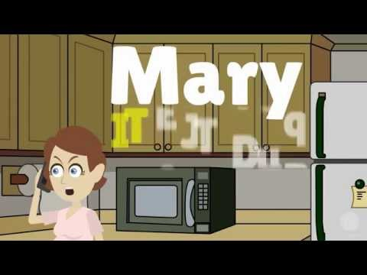](https://www.youtube.com/watch?v=We_m8tyMqcE)

Quiz: Present Continuous

<https://test-english.com/grammar-points/a1/present-continuous/>

**Writing activity:**

Write 5 sentences to describe things that your family members are doing right now. For example:

1. My mother is calling my dad through the phone.

Now, it is your turn.

SPEAKING ACTIVITY:

1. Go to Vocaroo: <https://vocaroo.com/>
2. Record an audio describing your daily routine.
3. Paste the like of your audio here (so the teacher can listen to the audio: _____________

**RECOMENDATIONS!**

* **Send this activity completed via e-mail. ---> alvaro.gonzalez@solvoglobal.com**
* **Include SCREENSHOTS of evidence when you complete the wordwall.**
* **Deadline is TOMORROW MIDNIGHT.**
* **La asistencia de esta clase independiente es el envío de la guía debidamente diligenciada.**